DA ASSIGNMENT 2

1. Donut Chart

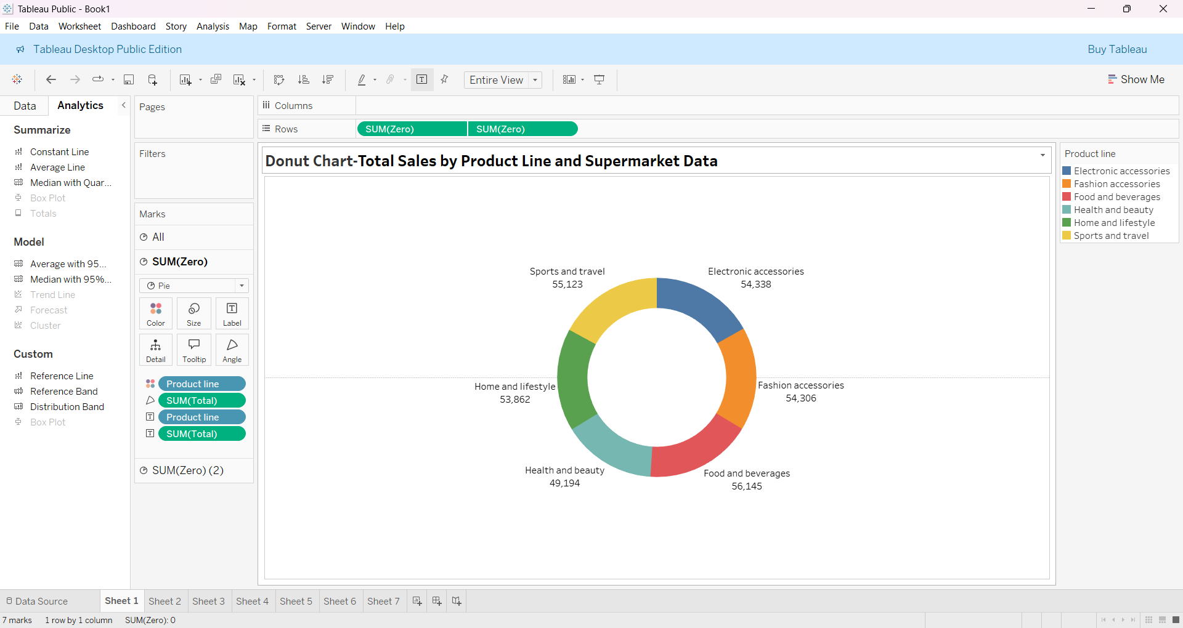

1. Area Chart

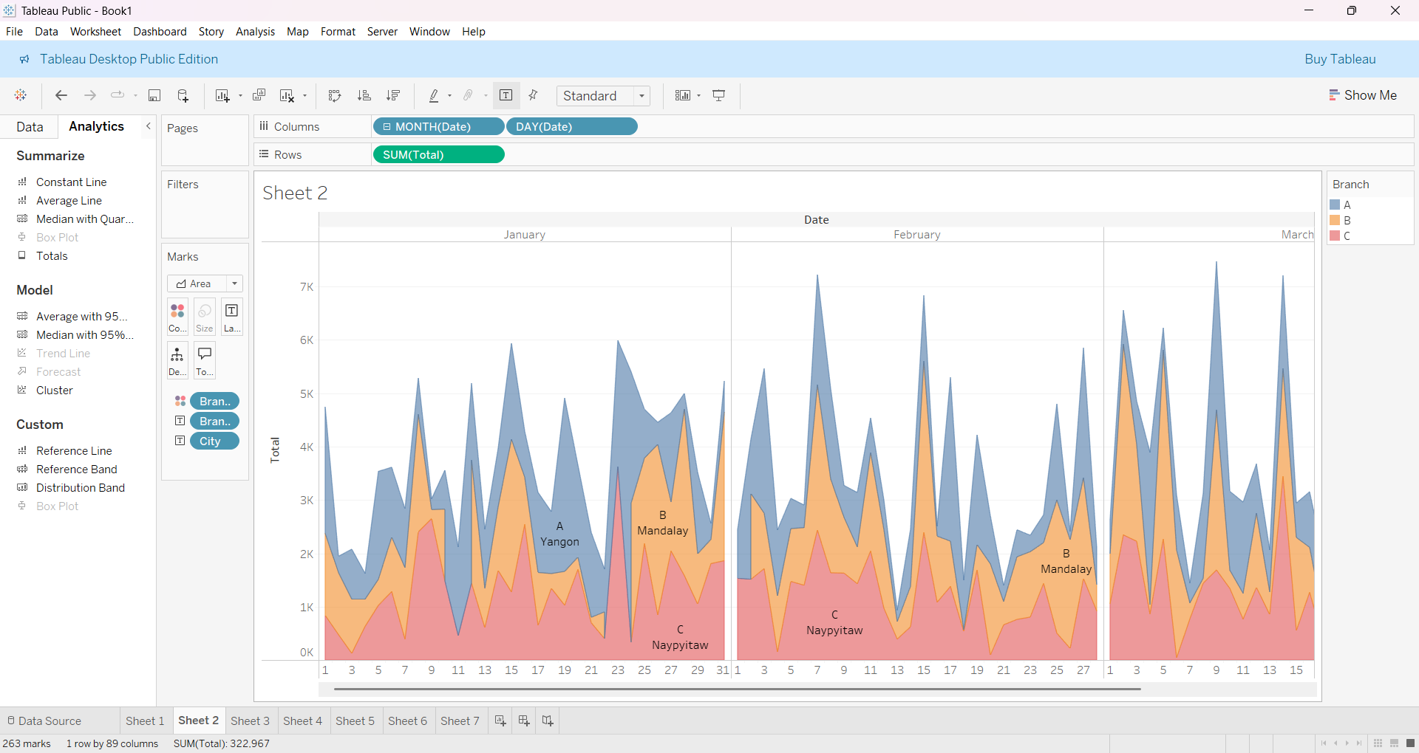

1. Text Table

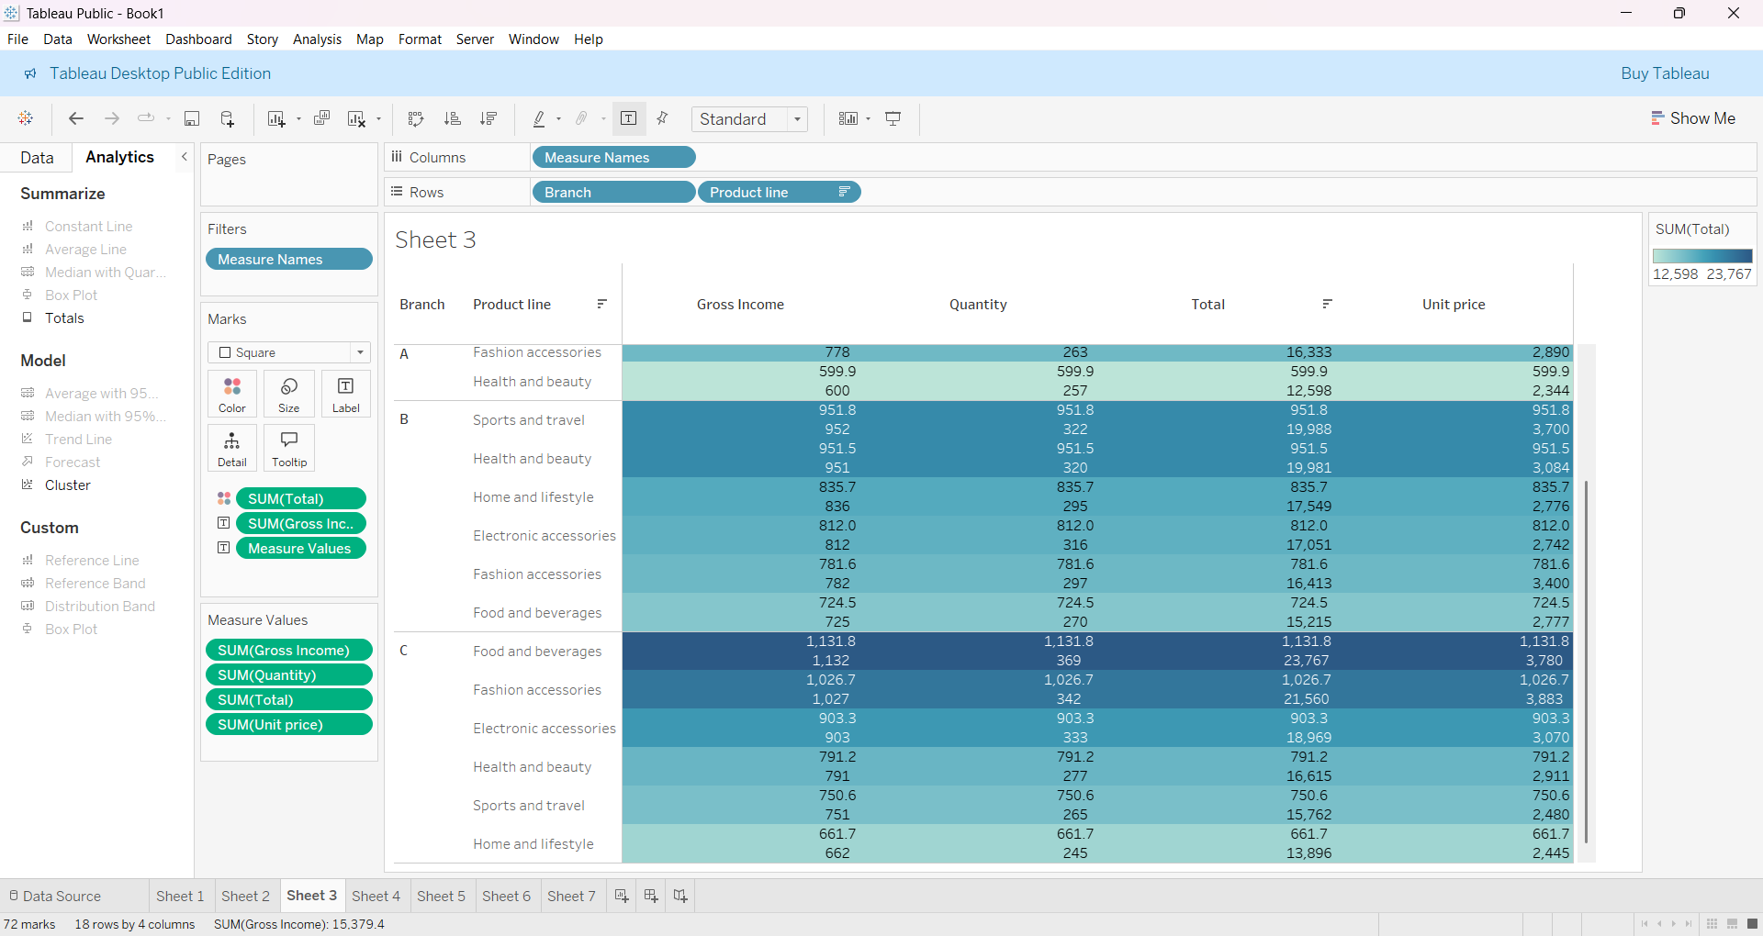

1. Highlighted Table

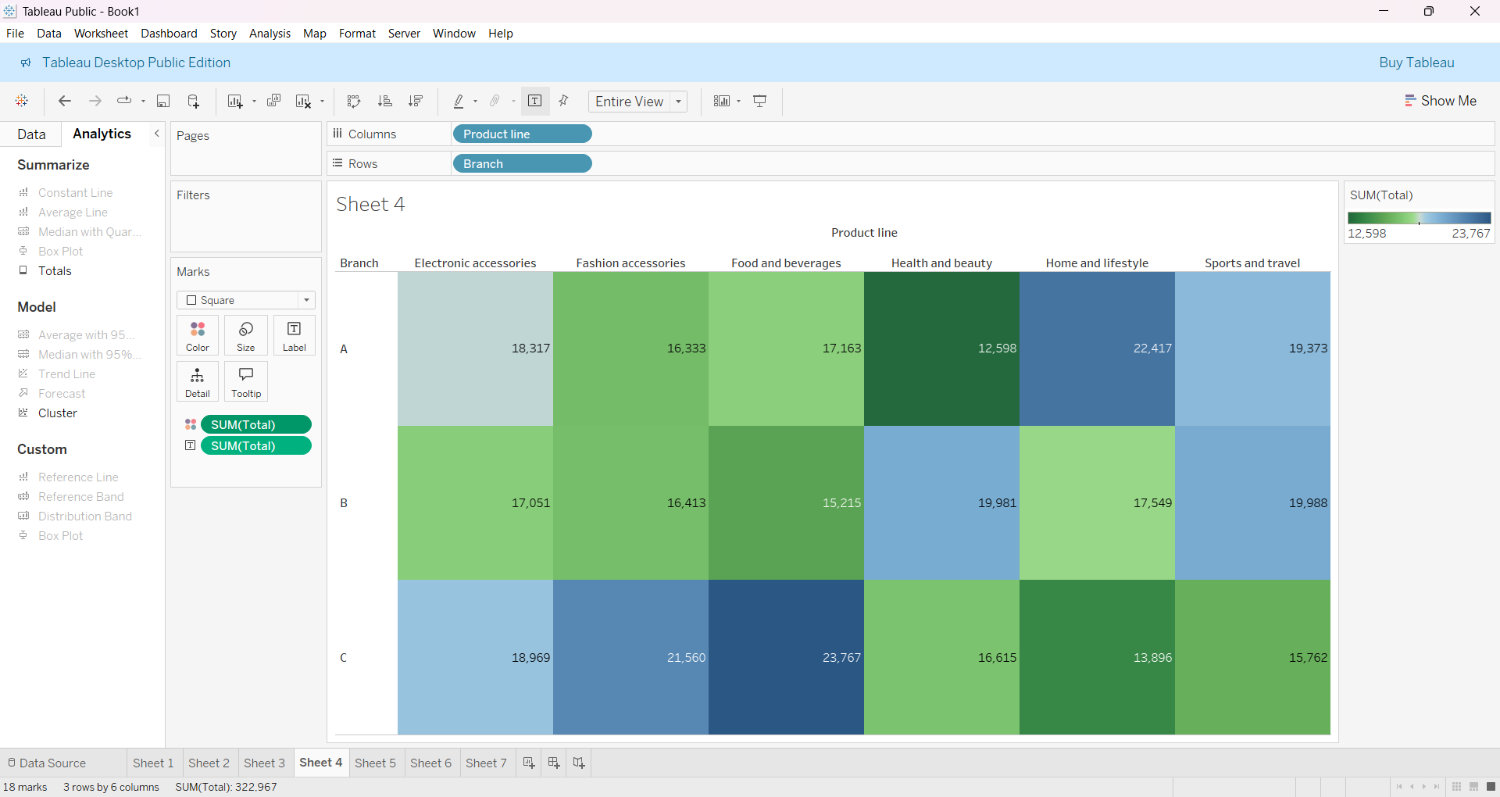

1. Word Cloud

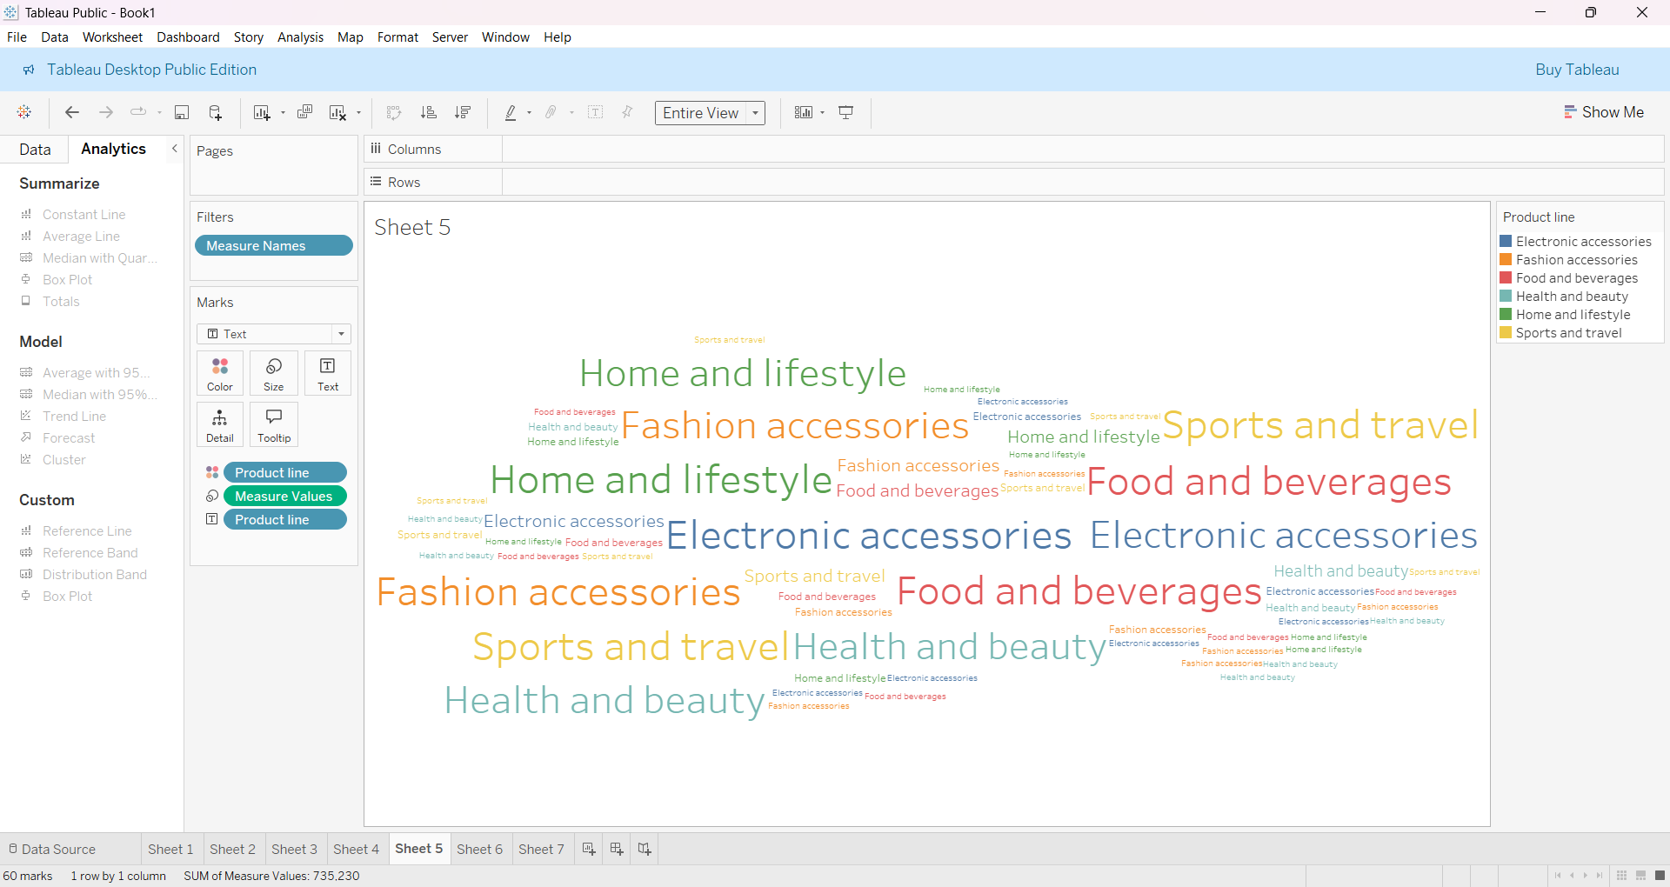

1. Funnel Chart

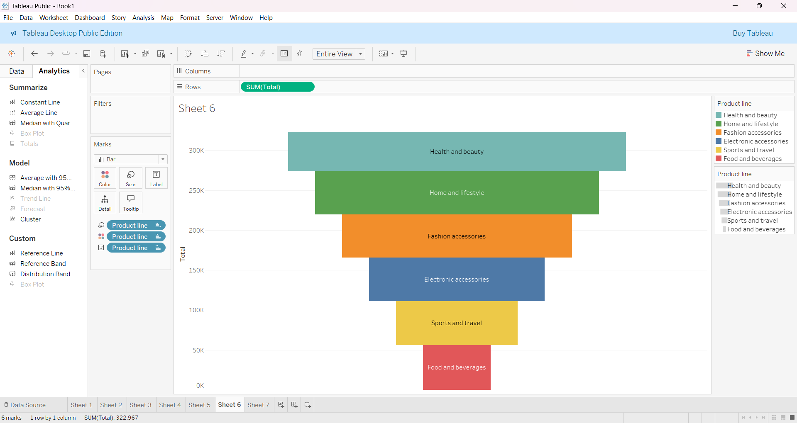

1. Waterfall Chart

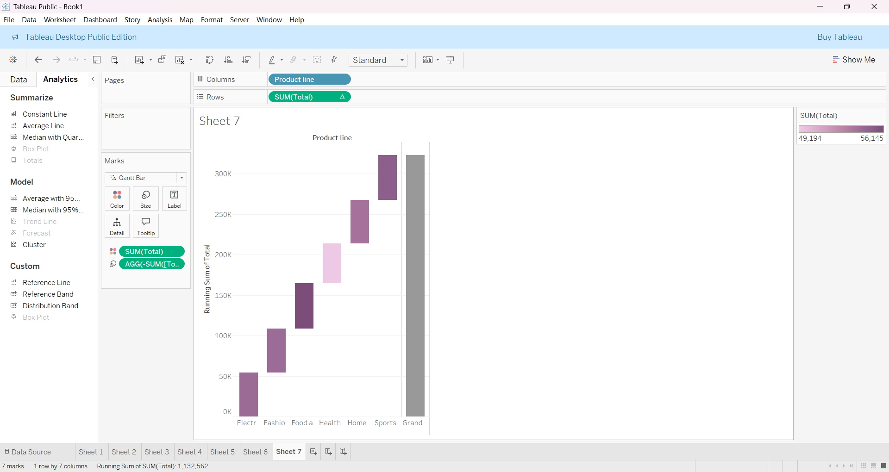

**Submitted by:**

**B.CHANDANASREE,**

**23AK5A0105.**